





Active and Passive Voice

What does a Verb do?

A verb tells us more about:

- What a person or thing is doing.
Ishan runs. The bell tolls.

- What is done to a person or thing.
The children are loved. The window is broken.
- What a person or a thing is.
The dog is beaten.
The cake is eaten.
I feel sick.

A verb can be used transitively or intransitively.

When a verb denotes an action passing from the doer (subject) to the object, it is a Transitive Verb.
- The guard stopped the man.
- The child kicked the cat.

When a verb denotes an action that does not pass from the doer (subject) to the object, it is an
Intransitive Verb.
- He spoke rudely.
- The guests arrived suddenly.

A verb can be used in the active or the passive voice.
A verb is said to be in the Active Voice when the subject is the doer of the action.
- Rustum made the bed for grandma.

A verb is said to be in the Passive Voice when something is done by the subject.
- Grandma’s bed was made by Rustum.

Active and Passive Voice - Usage

- The active voice is used when
The subject in the sentence needs to be highlighted.
  - Durga killed the mosquitoes.

- The passive voice is used when
The receiver of the action in the sentence needs to be highlighted.
  - The mosquitoes were killed by Durga.

NOTE:
The object of the verb in the active voice becomes the subject in the passive voice.

Only transitive verbs can be used in the passive voice.

Let us examine some sentences in the active and passive voice on the next page.

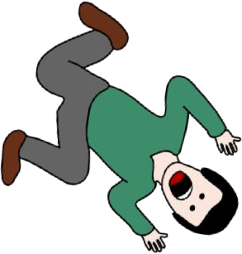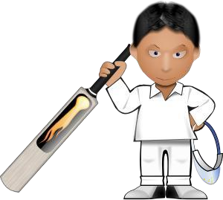Examples

Active: The guard shot the robber.
Passive: The robber was shot by the guard.

Active: Mr Morris solved the case.
Passive: The case was solved by Mr Morris.

Active: Yesterday Meera called me for lunch.
Passive: Yesterday I was called for lunch by Meera.

Active: Candy ate the cake.
Passive: The cake was eaten by Candy.

Active: Rahul scored a zero in the match.
Passive: A zero was scored by Rahul in the match.

Active: Diya wrote a poem for her teacher.
Passive: A poem was written by Diya for her teacher.

Active: Bad mood often spoils parties.
Passive: Parties are often spoilt by bad mood.

