






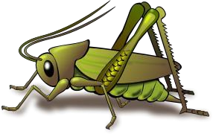
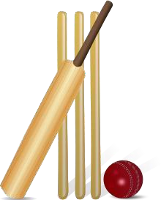
Homonyms and Homophones

What are Homonyms and Homophones?

- In English, words which share the same spelling and pronunciation but have different meanings are known as homonyms.
- Similarly, words which share the same pronunciation but have different spellings and meanings are known as homophones.
- Both the terms are derived from the Greek root words homo, nym and phone.

Homo (same) + Nym (name) | = | Homonym (same name)
Homo (same) + Phone (sound) | = | Homophone (same sound)

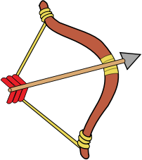
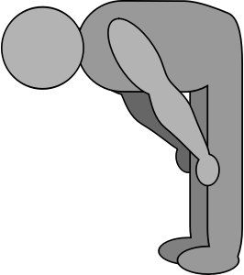
Examples of Homonyms

Bow (n) | Bow (v)
Cricket (n) | Cricket (n)
Rose (n) | Rose (v; past tense)

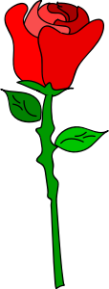



Grammer | Vocabulary

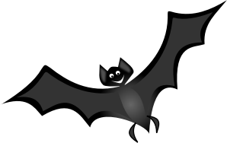Examples of Homonyms in Sentences

1. Mala did not bat an eyelid.
1. The bat flew into the room.
2. The cat will lie on the rug.
2. I dislike people who lie.
3. The landlord was a mean person.
3. He did not mean to hurt his friend.
4. Stalks of wheat swayed in the fields.
4. The hapless woman realised she was being stalked by a stranger.
5. I left my purse in Mrs Mishra’s house.
5. The spectators seated towards the left were very boisterous.

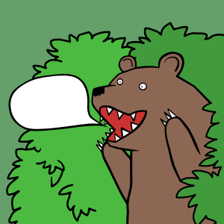
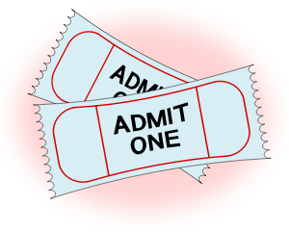
Examples of Homophones

Aloud | Allowed
Wine | Vine
Heel | Heal

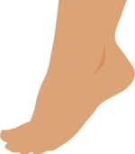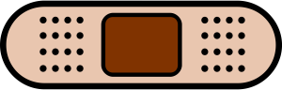

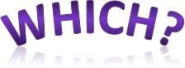
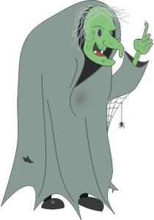



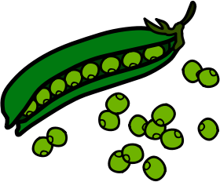
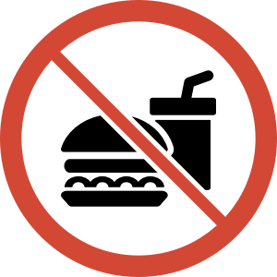
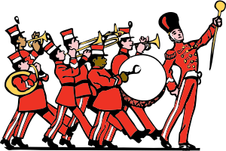
Which | Witch
Sale | Sail
Peace | Peas
Banned | Band
Ate | Eight

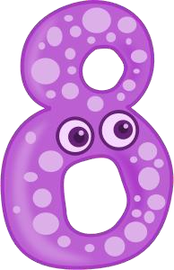

Grammer | Vocabulary

Examples of Homophones in Sentences


  - Accept this flower as a token of my gratitude.
- Except for a few mistakes, Rahul’s work is flawless.

- The old lady breaks the twig into half.
- The car swivelled around when its brakes failed.

- The cat tiptoed on its paws.
- The lawyer spoke after a long pause.

- There are no sellers available at this moment.
- Many of these old colonial style houses are equipped with cellars.

- The lone sheep strayed away from its herd.
- I heard what you said.

- The master strategist used his wiles against the evil assassin.
6. It took us a while to realise that we were heading in the wrong direction.

Commonly Confused Homophones

1. The Sharmas are proud of there daughter. | 
1. The Sharmas are proud of their daughter. | 
2. The subject peaked my interest.
2. The subject piqued my interest.
3. The employer wanted to know weather he could join immediately.
3. The employer wanted to know whether he could join immediately
4. The members gathered for the bored meeting.
4. The members gathered for the board meeting.

Idioms, Phrases and Proverbs

What are Idioms and Phrases?

In English, idioms, phrases and proverbs are used to enhance written and spoken communication.

- An idiom is a phrase whose figurative meaning is different from its literal meaning.
- A phrase can be a combination of a verb and an adverb, a verb and a preposition, and a verb with an adverb and a preposition.

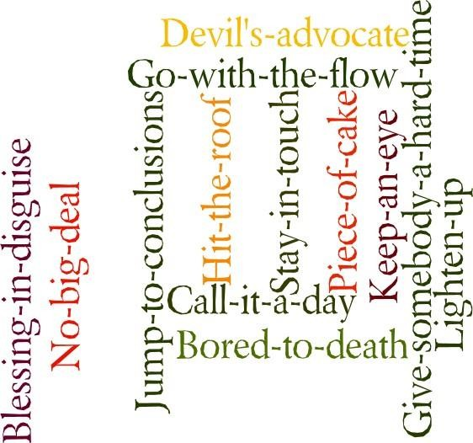

- Both idioms and phrases can have literal and figurative meanings.
- The only way to learn idioms and phrases is by reading about them and using them as much as you can.

Let us look at some phrases and idioms.

Phrases - Usage

Act on (produce effect) – The strong chemical acted on the marble surface.

Add to (increase) – The famine added to the misery of the farmers. Bear with (tolerate) – She bore with the shortcomings of her children. Blow over (to pass) – The wind blew over the fields.
Bring on (cause to bring) – Laziness brings on misfortune.

Cast off (abandon) – The son cast off his old parents.

Fall out (quarrel) – The partners fell out over disagreements on profit shares.

Get through (pass) – They got through the entrance examination. Hold up (stop) – The traffic was held up for an hour after the accident. Lay up with (confine to bed) – He is laid up in bed with fever.
Look over (examine carefully) – The supervisor looked over the checklists. Knocked about (wander about) – Kevin knocked about the town on Sundays. Part with (give up) – We parted with our land in hope of some fortune.

Strike at (aim at) – The clause strikes at concealing confidential information.

Grammer | Vocabulary

Phrases - Usage

Think over (consider) – Janet must think over her resignation before the meeting.

Treat to – Harold treated me to an ice cream on his birthday.

Suffer from – Mathew suffered from malnutrition while on war.

Work up (excite) – Gautam worked himself up into a fury during the debate.

At best – They were at best the most suitable candidates for the position.

Yield to (surrender) – Women yield to male dominance in some countries.

Turn aside (deviate) – She always turns aside from the main discussion during seminars.

Anything but (certainly not) – Shantaram was anything but a spy.

At one’s best – Sharon was at her best today at the recitation competition.

By far – This is by far the scariest movie I have seen alone.

For the most part – The discussion was for the most part useful.

In the guise of – Saloni went to the party in the guise of a man.

At loggerheads (hostile) – Sameer and Arya are at logger heads with each other.

On pretence of - The shopkeeper troubled Shyam on pretence of giving him work.


Grammer | Vocabulary

Idioms - Usage

College was very interesting, but the acid test will come when I get a job.

(The true test of the value or the quality of something)

It is mandatory. It is written in black and white in the contract.

(With a written proof)

Natasha pretended to be sad, but her mother knew her tears were crocodile tears.

(Pretend to be sad about something)

The employees were kept in the dark about the company’s falling profits.

(Not be informed about something that others know)

Of course, I am interested in the competition. I am all ears!

(Listening very attentively)

Jayant’s salary is so low that it is difficult for him to make both ends meet.

(Live within one’s income)

You have the face to come here after doing this to me?

(Be bold)

Driving alone on this road is playing with fire.

(Take risk)

Reactions to the campaign are arriving in fits and starts.

(Not continuous)

She is rude to her parents, but they just grin and bear it.

(Accept something bad without complaining)

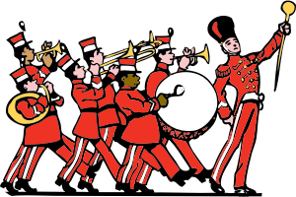
IDIOMS, PHRASES AND PROVERBS
ENGLISH
Grammer | Vocabulary

Idioms - Usage

I am writing about the issue, but I know it is flogging a dead horse.

(Wasting time in something that will not succeed)

She came in a huff and ordered something to eat.

(In an angry manner)

Saraswati cannot take a joke although she is famous for being cheerful in her group.

(Accept being made fun of in good humour)

Now that the project has failed, be ready to face the music.

(Accept unpleasant results of an action)

Aunt Kelly’s dresses are so out of date.

(Old-fashioned)

I’d like to have a shot at photography.

(Try something for the first time)

We have been given only a day to rework on this. That’s a tall order.

(Be very difficult to do)

You mustn’t tease him and rub him the wrong way.

(To irritate someone)

Those chairs we bought from Kenya are now white elephants.

(Something very expensive but a nuisance to keep)

Kevin won’t believe that I am unwell until he sees me. He is such a doubting Thomas.
(Someone who is always suspicious)


What are Proverbs?

A proverb is a simple statement based on facts and experiences which expresses truth and gives advice on life. You may have heard several proverbs in your moral science class. Let us read some proverbs and understand their meanings.

Fortune favours the brave.
Luck is more likely to be with those who take risks.

Don’t count your chickens before they are hatched.
You shouldn’t plan how to utilise good results of something before those results have occurred.

Honesty is the best policy.
Even if it may be useful to tell a lie, you should always tell the truth.

Slow and steady wins the race.
Constant and regular work leads to better results.

Empty vessels make the most noise.
People who have little knowledge usually talk the most and make the greatest fuss.

There is no such thing as a free lunch.
Things which are offered free always have a hidden cost.

God helps those who help themselves.
Work hard to achieve your goals. Don't just wait for good things to happen to you.

Practice makes perfect.
You have to practice a skill a lot to become good at it.

Beauty is in the eye of the beholder.
Different people have different ideas about what's beautiful.

Necessity is the mother of invention.
When you are really in need, you think of creative solutions to your problems.

A chain is only as strong as its weakest link.
If one member of a team doesn't perform well, the whole team will fail.

Why Use Idioms, Phrases and Proverbs?

Figurative language
- uses fewer words to express more
- is used to share old wisdom and universal ideas
- helps break the monotony of normal writing
- makes writing more visual and enjoyable for readers
- makes the text colourful
- paints a mental picture of the writer’s ideas for readers



English Affixes

Prefix and Suffix

- In any language, the system responsible for building vocabulary by affixing groups of words to root words or base words is known as the affixation system.

Unbelievable | Non-existent
Digression | Asocial
Favourable | Youthful

- This system is made of prefixes, suffixes, root words and base words.
- The knowledge of English affixation offers us a systematic and effective way of expanding our vocabulary without having to remember a large number of words at a time.
- Though many words in English do not have affixes (chair, bag, horse, time), there are many others which do (return, demonstration, undo).
- English borrows heavily from languages such as Latin and Greek.
- Most of the word roots in English can be traced back to these two languages.
- Through this chapter, we will learn the common prefixes, suffixes and root words which constitute English.

Prefixes

- A prefix is a group of letters which is fixed at the beginning of the root or base word.
- The term ‘prefix’ is derived from the Greek root words ‘pre’ which means ‘before’ and ‘fix’ which literally means ‘to fix’.

Uncertain | Irreplaceable | Bifocal
Antisocial | Misunderstand | Retreat
Subtract | Ambivalent | Proceed

Functions of Prefixes

- Prefixes can indicate the presence or absence of an idea.

Amoral (without morals) | Non-existent (not existing)
Unimportant (trifling) | Incorporated (taken in)

- Prefixes can indicate position.

Dethroned (off the throne) | Submarine (under water)
Superimpose (kept on top) | Paramilitary (alongside military)

- Prefixes can also indicate characteristics or qualities.

Antibacterial (resistant to bacteria) | Biannual (twice every year)
Congenital (with birth) | Transparent (can see across)

List of Common English Prefixes

Prefix | Meaning | Words | Prefix | Meaning | Words
a-, an- | Not, without | Amoral Amorphous  Anarchy | anti-, ant- | Against | Antibacterial Antipathy  Antagonist
ante- | Before | Antechamber  Ante mortem Ante bellum | auto- | Self | Automatic  Autocrat Autonomy
bi- | Two | Biannual  Bicycle Binoculars | bio- | Life | Biology  Biotic Biogenetics
co-, com-, con- | Together, Joint | Cooperate Company Conjoined | contra- | Against | Contradict Contravene Contravene  Contrast
demi- | Half | Demigod | de- | Down | Decrease  Decline Degrade
dis- | Off | Dispose  Disappear Disturb | e-, ex- | Out | Eject  Express Extract
en- | To do, to put | Endanger Enchanted Enable | extra- | Beyond | Extra- terrestrial Extracurricular

Prefix | Meaning | Words | Prefix | Meaning | Words
hemi- | Half | Hemisphere  Hemicycle | hepta- | Seven | Heptagon  Heptarchy
hyper- | Over | Hyperbole Hyperactive Hyperlink | in-, ill-, ir-, im- | Not | Incapable Illogical Irrelevant  Impossible
in-, im- | Inside/into | Internal  Indoctrinate Impregnate | inter- | Between | Interschool  International Interconnected
mono- | Single/one | Monogram  Monarch Monopoly | mega- | Huge | Megawatts  Megabyte Megacity
micro- | Small | Microscope Microbiology Microorganism | non- | Not, without | Nonstop Nonsense Non-  vegetarian
omni- | All | Omnipotent Omniscient  Omnipresent | ob- | Bad, wrong | Obstruct Obnoxious  Obdurate
para- | Along | Paramilitary  Parallel Parapet | pre- | Before | Prevent  Prepare Predict
post- | After | Postcolonial  Post mortem Post-partum | poly- | Many | Polygon  Polyglot Polymath
re- | Again | Replay  Regain Return | retro- | Back | Retrogress Retrograde
sub- | Under | Subway  Subtract submarine | super- | Over, above | Supersede  Superman Superfluous
syn-, sym- | Together | Synthesis  Synchronise Sympathy | semi- | Half | Semicircle  Semisolid Semisweet

Prefix | Meaning | Words | Prefix | Meaning | Words
tri- | Three | Tricycle  Triangle Trinity | tetra- | Four | Tetra pack  Tetrapod Tetrad
trans- | Across | Transparent  Translucent Transport | uni- | One | Unity  Unicycle Universe
un- | Not | Unfinished  Unspoken Uninterrupted | zoo- | Animal | Zoophilic  Zoology Zoo

Suffixes

- A suffix is a group of words which is fixed at the end of the root or base word.
- The term suffix is derived from the Greek root words ‘sub’ which means ‘under’ and ‘fix’ which literally means ‘to fix’.

Generous | Happiness
Decency | Grateful

Functions of Suffixes

- Suffixes can change the part of speech of a particular word.

Adequate (adjective) | Adequacy (noun) | Adequately (adverb)
Tolerable (adjective) | Toleration (noun) | Tolerate (verb)
Supreme (adjective) | Supremacy (noun) | Supremely (adverb)
Demonstrable (adjective) | Demonstration (noun) | Demonstrate (verb)

- Suffixes can indicate the number of the noun whether it is singular or plural.

Fox (singular) | Foxes (plural)
Ox (singular) | Oxen (plural)

- Suffixes can indicate the tense of verbs.

Toast (present) | Toasted (past)
Freeze (present) | Freezing (continuous)

List of Common English Suffixes

Suffix | Meaning | Words | Suffix | Meaning | Words
-able (adj) | Having the quality | Unspeakable  Admirable Amicable | -acy (n) | Quality | Delicacy  Privacy Accuracy
-est (adj) | Highest degree | Biggest  Greatest Fastest | -ance, -ence (n) | State or quality | Maintenance  Absence Difference
-dom (n) | Place or state | Freedom  Kingdom Boredom | -ful (adj) | Full of | Graceful  Tactful Beautiful
-er, -or, -eer,  -ier (n) | Doer, one who | Trainer Actor Charioteer  Chocolatier | -ism (n) | Belief system | Capitalism Hinduism Marxism
-ist (n) | One who | Pianist  Terrorist Chemist | -ity, -ty (n) | Quality of | Duplicity  Ability Enmity
-ish (adj) | Like | Ticklish  Boyish Reddish | -less (adj) | Without | Fearless  Blameless Toothless
-ly (adv) | In the manner of | Beautifully Sadly  Slowly | -hood (n) | State | Childhood Neighbourhood  Sainthood
-ate (v) | To do/make | Create Elevate  Punctuate | -en (v) | To make/become | Enliven Frozen  Sunken
-kin (n) | A person | Bumpkin | -ed (v) | To do/make | Toiled  Cooked Walked
-ee (n) | A person who | Employee  Divorcee Examinee | -fy, -ify (v) | To do/make | Verify  Clarify Horrify

-ward | In the  direction of | Eastwards  Towards Downwards | -ean, -ian (adj) | To have the  quality | Vegetarian  Herculean Cyclopean

Root Words and Base Words

- Root words and base words are the parts which contain the primary meaning of the word.
- Prefixes and suffixes are added to the root and base words to create new words and ideas.

Root Word
- A root word cannot stand on its own as an independent word.
- It needs the addition of the prefix or the suffix for the completion of its meaning.
- For example, let us take the words Geologist and Carnivorous.

Geo - | -log- | -ist | Carni- | -vor - | -ous-
(root) | (root) | (suffix) | (root) | (root) | (suffix)

- In the above cases, the roots geo-, -log-, - carni- and -vor- cannot stand alone as individual words.
- They are therefore known as root words.

Base Word
- A base word, unlike a root word, can stand on its own like an independent word.
- It does not need the addition of the prefix or the suffix to function as a stand-alone word.
- For example, let us take the words Undo, Precook, Counterattack and Superscript.

Pre | cook | Counter | attack | Super | script
(prefix) | (base word) | (prefix) | (base word) | (prefix) | (base word)

- In the above cases, do, cook, attack and script can all function as meaningful words.
- They are therefore known as base words.

List of Common Root Words and Base Words

Root | Meaning | Words | Root | Meaning | Words
-acr-,- ac- | Sharp, bitter | Acrid  Acronym Acute | -ami-,-amo- | Love | Amiable  Amicable Amorous
-ambi-,  -amphi- | Both | Ambivalent Amphibious | -aster- | Star | Asteroid Disaster  Astrology
-bene - | Good | Benevolent  Benefit Benign | -chrono- | Time | Chronology  Chronicle Synchronise
-circ- | Around | Circumnavigate  Circumstances Circumference | -dict- | Speak | Dictate  Dictator Diction
-duc- | Lead | Duct  Abduct Induct | -gen- | Create/birth | Hydrogen  Generate Gene
-geo- | Earth | Geography  Geologist | -graph- | Write | Calligraphy  Graphology
-jur-, -jus-, - jud- | law | Jury  Justice Judge | -log-, -logy- - ist | Study | Biology  Zoology Psychologist
-luc- | Light | Translucent Lucid | -man- | Hand | Manacles Manuscript  Manual
-mis- | Hatred, wrong | Misanthrope  Misinform Mistake | -mit-, -mis- | Allow | Permit Admit  Transmission
-path- | Feel | Sympathy  Empathy Antipathy | -phil- | Love | Philosopher  Philology Bibliophile
-photo- | Light | Photosynthesis  Photograph Photon | -scribe- | Write | Scribe  Scribble Inscribe

-sent-, -  sense- | Feel | Sentimental  Sensational Sensible | -tele- | Long  distance | Telephone  Telescope Television
-terr- | Land, ground | Territory  Terrestrial Terrace | -vac- | Empty | Vacation  Vacant Evacuate
-vid-, -vis- | See | Video  Visual Visible | -vol- | Fly | volley

How to Use the Affixation System

- Thorough knowledge of the English affixation system helps us in guessing the meaning of the word purely by the means of its prefix-root-suffix structure.
- Because of the limitations of our memory, it is not easy to remember a large number of words at a time.
- We may find it difficult to associate the meaning of the word with its structure.

Word | Meaning
Subterranean | Underground

- With the knowledge of the affixation system, we can guess the meaning of the given word.

Prefix | Root | Suffix
Sub- | -terran- | -ean
(under) | (ground) | (adj)

The meaning of the above word is ‘Underground’, and it is used as an adjective.

Thus, to have a rich vocabulary, students should learn the prefix-root-suffix method. It is an interesting way to expand your vocabulary with little effort. Students who are well-versed with the affixation system find it easier to tackle difficult words and are more confident about their word usage. It will definitely give you an edge over the others when it comes to words.

Synonyms and Antonyms

What are Synonyms?

Synonyms are words or phrases which are used as substitutes for another. Sometimes, synonyms need not mean exactly the same as the other word. They can also be a close substitute for the other word.

Synonyms can belong to any word category:

Category | Word | Synonym | Synonym
Noun | Pauper | Destitute | Beggar
Adjective | Bright | Dazzling | Luminous
Verb | Laugh | Chuckle | Snigger
Adverb | Beautifully | Exquisitely | Charmingly

Why do Synonyms Exist?

English is a language which has many influences since it has evolved in a natural manner. Today, it is a combination of languages such as Latin, Greek, Celtic, French, Scandinavian and even Hindi. Some words in English are adopted from these languages in addition to the ones which already exist. For example, mansion is a word which is adopted from French. At the same time, its synonym bungalow is taken from Hindi.

What are the Uses of Synonyms?

Why are synonyms used when one word can convey the idea perfectly? Let us find out.

Situation
Let us consider the words check and investigate. Though both the words are synonyms of each other, we cannot substitute one for the other in certain situations.

Examples:

A
I will check if there is something to eat in the kitchen.
B
I will investigate if there is something to eat in the kitchen.

C
Inspector Sahasrabuddhe will check the robbery attempt.
D
Inspector Sahasrabuddhe will investigate the robbery attempt

Grammer | Vocabulary

In the above examples, the usage of the word check in sentence A seems appropriate. Its synonym investigate sounds awkward and pompous in sentence B. Similarly, in sentence C the word check lacks the force of the word investigate which is used in sentence D. In conclusion, we can say that it is the situation that dictates which word or its synonym has to be used.

Tone
Sometimes a word does not do justice to the emotion behind it. The tone or the emotion behind a person’s voice can also dictate which word has to be used.
Examples: Dislike, hate, despise
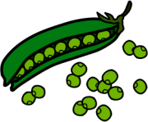

- Manohar dislikes peas. (Does not like peas)

- Manohar hates peas. (Intensely dislikes peas)

- Manohar despises peas. (Has a very strong and personal hatred towards peas)
Although the three highlighted words are synonyms, they have different tonalities. Hence, one cannot use the word dislike to describe a very strong and personal hatred.

Sound
We use a certain word instead of its synonym because it sounds more pleasing. Examples:

B. A group of idiots

A. A confederacy of dunces
In the above examples, group and idiots are synonyms of confederacy and dunces, respectively. Sentence A sounds more appealing than sentence B because of the choice of words. Hence, it is important that we use synonyms sometimes to make sentences sound more pleasing.

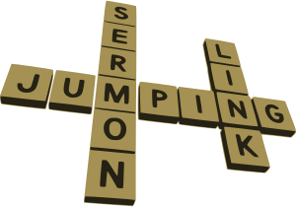
We can conclude by saying that synonyms make the language rich in meaning by adding variety to it. It also helps the speakers express themselves better and more clearly. The speakers can assess the situation and use appropriate words to deliver the exact message they wish to express.

Grammer | Vocabulary

What are Antonyms?

In contrast with synonyms, antonyms are words or phrases which are opposite in meaning to another. This may sound strange, but often, to understand a word better, we have to look at its antonym. We learn the meaning of the word by understanding how it contrasts with its antonym.

Example:
Cantankerous: kanˈtaŋk(ə)rəs Opposite of good-natured
Sometimes, to understand a word better, it is important that we look up its antonym along with its synonym. Like synonyms, there can be more than one antonym for a given word.

Category | Word | Antonym | Antonym
Noun | Odour | Fragrance | Aroma
Adjective | Jubilant | Morose | Depressed
Verb | Create | Destroy | Annihilate
Adverb | Excitedly | Nervously | Anxiously

What are the Different Types of Antonyms?

There are three basic types of antonyms:
- Gradable antonyms
- Complementary antonyms
- Relational antonyms

Gradable Antonyms
Gradable antonyms are words which are the extreme opposites of each other. Imagine a spectrum or a scale. Gradable antonyms will be at equal distances from the centre on the scale. However, these words may have a spectrum of words between them. All these words may exist together on the same scale.



Hot Warm Cool Cold

In the above example, hot is the polar opposite of the word cold. But together, they exist on the same spectrum as warm and cool. Let us look at more examples of gradable antonyms.

Good | Bad | Depressed | Joyful | Intelligent | Foolish
Evil | Saintly | Young | Old | Excited | Bored

Complementary Antonyms
Unlike gradable antonyms which have a spectrum of words between them, complementary antonyms are words which express two extreme ideas without the possibility of ‘middle’ words. They do not lie on a continuous scale and are the exact opposites of each other.

Let us look at a few examples of complementary antonyms.
Inhale | Exhale | Dead | Alive | Exit | Enter | Right | Wrong
Vacant | Occupied | Similar | Different | Sink | Float | Married | Single

Relational Antonyms
Relational antonyms are words which are opposite to each other by the virtue of their relationship alone. One finds meaning through the existence of the other. For example, the word up exists in relation to the word down.

Let us look at a few examples of relational antonyms.
Teacher | Student | Husband | Wife | Slave | Master | Parent | Child
Buy | Sell | Buy | Sell | Predator | Prey | North | South

Synonyms and Antonyms

We shall now look at common synonyms and antonyms used in everyday life.
able (adj) Synonyms good Antonyms disinclined
skilled
adequate
unskilled
inadequate
abnormal (adj) Synonyms unusual Antonyms usual
anomalous
weird
normal
common
accomplish (v) Synonyms do Antonyms begin
finish
attain
halt
destroy
abandon (v)

Synonyms leave Antonyms take up
neglect
drop
pursue
adopt
amusement (n) Synonym delight Antonym boredom
enjoyment
glee
gloom
sadness
baffle (v)

Synonym amaze Antonym clarify
mystify
confuse
clear up
explain
baleful (adj) Synonyms deadly Antonyms harmless
dangerous
evil
safe
banal (adj) Synonyms boring Antonyms interesting
common
bland
origin
new
banish (v) Synonyms dismiss Antonym accept
dispel
remove
admit
allow
coarse (adj) Synonyms rough Antonyms smooth
bumpy
rugged
refined
fine
candid (adj) Synonyms frank Antonyms biased
honest
sincere
devious
false
chaos (n) Synonyms turmoil Antonyms harmony
disarray
disorder
organisation
orderliness
celestial (adj) Synonyms heavenly Antonyms awful
angelic
holy
bad
horrible
cease (v) Synonyms stop Antonyms begin
halt
discontinue
continue
do


Grammer | Vocabulary
deadly (adj) Synonyms dangerous Antonym safe
cruel
destructive
dumb (adj) Synonyms mute Antonyms sharp
quite
mum
kind
strong
talkative
speaking

depart (v) Synonyms leave Antonyms arrive
escape
exit
come
enter
decay (n) Synonyms decompose Antonyms grow
rot
break down
build
mature
detailed (adj) Synonyms accurate Antonyms inaccurate
complex
exact
simple
false
demise (n) Synonyms death Antonyms birth
end
downfall
start
rise
endure (v) Synonyms bear Antonyms halt
brave
face
refuse
deny
eccentric (adj) Synonyms strange Antonyms common
outlandish
odd
familiar
ordinary
edible (adj) Synonyms eatable Antonyms inedible
consumable savoury
unpalatable
harmful
fabricate (v) Synonyms create Antonyms demolish
concoct
make
ruin
destroy
fact (n) Synonyms evidence Antonyms lie
information
matter
fabrication
fallible (adj) Synonyms faulty Antonyms perfect
incorrect
imperfect
correct
perfect


flabbergasted (adj) Synonyms surprised Antonyms bored

taken aback dumbfounded clarified explain
faction (n)

Synonyms part Antonyms whole
bloc
sect
entirety
unity

general (adj) Synonyms broad Antonyms
specific

generic commonplace

different extraordinary
garb (n) Synonyms clothes Antonyms
reality

disguise garments


Grammer | Vocabulary
garnish (v) Synonyms decorate Antonyms ruin
adorn
enhance
gloat (v) Synonyms brag Antonyms be sad
exult
relish
disfigure
worsen
be glum
be upset

gaudy (adj)

Synonyms bright Antonyms dull
flashy
garish
refined
modest
genial (adj) Synonyms friendly Antonyms hostile
amiable
cheerful
rude
nasty
hasty (adj) Synonyms impatient Antonyms patient
hurried
reckless
cautious
slow
habitual (adj) Synonyms chronic Antonyms temporary
addicted

inhabitual
infrequent
hale (adj)

Synonyms healthy Antonyms unhealthy
fit
robust
unfit
sick
industrious (adj) Synonyms hardworking Antonyms lazy
diligent
productive
inactive
negligent
invite(v) Synonyms call Antonyms discourage
attract
persuade
ignore
reject
ignite (v) Synonyms set ablaze Antonyms put out
burn
kindle
extinguish
quench
jest (n) Synonyms joke Antonyms seriousness
fun
gag
work
gravity
jibe (n) Synonyms insult Antonyms appreciation
remark
abuse
flattery
honour
jovial (adj) Synonyms happy Antonyms morose
joyful
blissful
sad
depressed
kindle (v) Synonyms stoke Antonyms put out
light
ignite
extinguish
snuff

27
king (n) Synonyms emperor Antonyms subject
Ruler
Monarch
knack (n) Synonyms expertise Antonyms inability
flair
skill
ineptitude
incapacity

lavish (adj) Synonyms generous Antonyms modest
luxuriant
grand
austere
economical
liberal (adj) Synonyms free Antonyms orthodox
broadminded flexible
narrow minded
rigid
linger (v) Synonyms stay Antonyms vanish
remain
persist
go
leave
misogamist (n) Synonyms marriage hater Antonyms believer of marriage
sceptic
pessimist
confident
optimist
monotony (n) Synonyms boredom Antonyms excitement
dullness
routine
change
variety
meagre (adj) Synonyms less Antonyms much
few
insufficient
many
sufficient
neglect (n)

Synonyms leave Antonyms take up
abandon
carelessness
adopt
care
negotiate (v)

Synonyms agree Antonyms disagree
discuss
consult
block
ignore
naïve (adj) Synonyms innocent Antonyms artful
simple
ignorant
cunning
smart
object (v) Synonyms disagree Antonyms agree
contradict
clash
accept
approve
omnipotent (adj) Synonyms all powerful Antonyms weak
almighty
supreme
impotent
feeble
onset (n)

Synonyms starting Antonyms end
beginning
birth
finish line
death

28
philanthropis t (n) Synonyms generous
social servant
humanitarian
Antonyms
villain malefactor antisocial person
pessimist (n)

Synonyms
cynic
worrier
complainer
Antonyms
optimist
positive person
hoper

precise (adj) Synonyms exact Antonyms imprecise
same
accurate
uncertain
inaccurate
quest (n) Synonyms expedition Antonyms retreat
search
adventure
retirement
withdrawal
reveal (v) Synonyms show Antonyms hide
expose
divulge
withhold
conceal
recount (v) Synonyms convey Antonyms repress
narrate
describe
hide
conceal
rural (adj)

Synonyms simple Antonyms urban
village-like
rustic
modern
civic
scrupulous (adj) Synonyms moral Antonyms unscrupulous
upright
precise
dishonest
careless
scurry (v) Synonyms run
scamper
hurry
Antonyms
dawdle
stay
walk
simpleton (n) Synonyms simple-minded person Antonyms smart
foolish
gullible
sophisticated
cunning
tender (adj) Synonyms soft Antonyms hardened
delicate
raw
rough
calloused
trot (v) Synonyms walk briskly Antonyms dawdle
jog
hurry
stop
walk slowly

unanimous (adj) Synonyms together Antonyms single-handed
timid (adj) Synonyms frightened Antonyms brave
meek
fearful
brazen
audacious

united collective

alone divided

unruly (adj)
Synonyms
uncontrollable unmanageabl lawless
e
Antonyms
disciplined controllable calm
unique (adj) Synonyms one of a kind
special
peculiar
Antonyms
common
banal
similar

29
vain (adj)
Synonyms
self-absorbed self-
arrogant
vacate (v) Synonyms retreat
empty
depart

obsessed
Antonyms
humble
modest
shy
Antonyms
arrive
occupy
come
Grammer | Vocabulary

vibrant (adj) Synonyms colourful Antonyms dull
exciting
lively
boring
monotonous
wander (v) Synonyms roam Antonyms go directly
walk around stray
withhold (v) Synonyms keep back Antonyms give
conceal
not give
show
exhibit
wrangle (v) Synonyms fight Antonym agree
quarrel
brawl
concede
get along

The Same Word Used as Different Parts of Speech

Content and Function Words

In English, a word can be either a content word or a function word.
Content Words Show Information and Meaning
Nouns Main Verbs Adjectives Adverbs
house, Pavan, summer, student swim, race, eat, frighten
beautiful, thin, expensive, naughty fast, carefully, late, often
Function Words Make our Sentences Grammatically Correct
Auxiliary Verbs Articles Conjunctions Prepositions Pronouns
do, be, have a, an, the
and, but, for, though in, on, over, beside you, him, her, they
The combination of these words helps us to form different sentence structures.

They have a beautiful house.
Do you know you are thin because you eat fast? What a naughty student Pavan is!
They often swim in the lake during summer.

Parts of Speech

Form and content words are further classified into different classes called parts of speech. There are eight parts of speech in English:

- Noun
- Adjective
- Pronoun
- Verb
- Adverb
- Preposition
- Conjunction
- Interjection

The same word can belong to different parts of speech according to how it is used in sentences. Let us see how.
Above
The stars are above. (Adverb)
The founders’ authority is above the management’s. (Preposition) Rewrite the above examples. (Adjective)
Our luck comes from above. (Noun)
The function of a word in a given sentence determines which part of speech it
belongs to.

Identifying the Function of a Word

A word used as a noun in a sentence will answer the question ‘what?’ and will usually be the subject of the sentence.

If the word is used as an adjective, it will answer the question ‘what kind of/how much?’ and will describe the noun/s in the sentence.

When used as an adverb, a word will answer the question ‘how?’ and will tell you more about the verb in a sentence.

Let us look at a few examples:
Round
Adjective Noun Adverb
I have a round dining table. (what kind of table?)
Cut the candles into rounds. (into what?)
An eagle circled round overhead. (how did it circle?)

A word used as a verb will show an action performed by the noun.

A word which is used as a preposition will show location, time and movement. A word used as a conjunction will connect phrases and sentences.
Let us look at a few examples:

Except

Verb Preposition Conjunction

If we except Sumed, all are to be blamed. All the soldiers returned except Hemant.
I didn’t say anything except that you are unwell.

Adverb or Preposition?

Some words can be used as both prepositions and adverbs.

Before
Preposition Adverb
She had to rest before her flight. We have met each other before.
After
Preposition Adverb
Shortly after Partition, they moved to Pakistan. The Duke died soon after.

Near
Preposition Adverb
His house is near the bank.
A building crashed somewhere near.

Like
Preposition Adverb
Do not shout like that.
And then he said I was right! I was like so shocked!

Noun or Verb?

Some words can be used both as nouns and verbs.
Race
Noun Verb
Wasim won the race by a margin of 2 seconds.
The children were asked to race towards the finishing line.

Love
Noun Verb
Mother’s love is selfless. I love eating fresh fruits.
Box
Noun Verb
Do not touch the orange box.
I will box your ears if you don’t listen to me.

Grace
Noun Verb
Ishani performed her dance with grace. Please grace the occasion with your presence.

The following are some commonly used words which can be used as different parts of speech.

All

Adjective All children are requested to maintain silence.
Adverb She was all alone in that dingy lane.
Pronoun All spoke in his favour.
Noun All was lost in the war.

Better

Adjective We are hoping for better facilities here.
Adverb I am sure you know better.

Noun The sooner the better.
Verb His account can hardly be bettered.

Down

Adverb Sit down and stop shouting.

Preposition The drawer came crashing down the stairs. Adjective I have to catch the down train in twenty minutes. Verb Down with the injustice!
Noun They have had many ups and downs in life.

Either

Adjective Either offer is good enough. Conjunction Ravi must either sign the contract or quit. Pronoun They must either beg or starve.

For

Preposition She writes books for children.
Conjunction Thank Mr Shah, for he saved the day.

Much

Adjective There was much sense is what you said.
Adverb Did it hurt very much?
Pronoun You must bear much of the blame.

Neither

Conjunction Gauri will neither come home nor stay at your place.
Adjective Neither side was prepared for the war.
Pronoun Neither of us believes you.

Once

Adverb She was young and beautiful once. Conjunction Once the juice was served, breakfast began. Noun Can you support me for once?

