






Types of Sentences – Based on Form

What is a Sentence?

A sentence is a group of words which makes complete sense.

It contains a subject and a verb, and may also contain an object.

Examples:

Kavita plays. (S + V)
Kavita plays the piano. (S + V + O) Ravi kicks.
Ravi kicks the ball.

Sentences can be categorised based on
- Meaning
- Form

Based on meaning, sentences can be declarative, interrogative, imperative, exclamatory and optative. Let us see how sentences are categorised based on their form and characteristics.
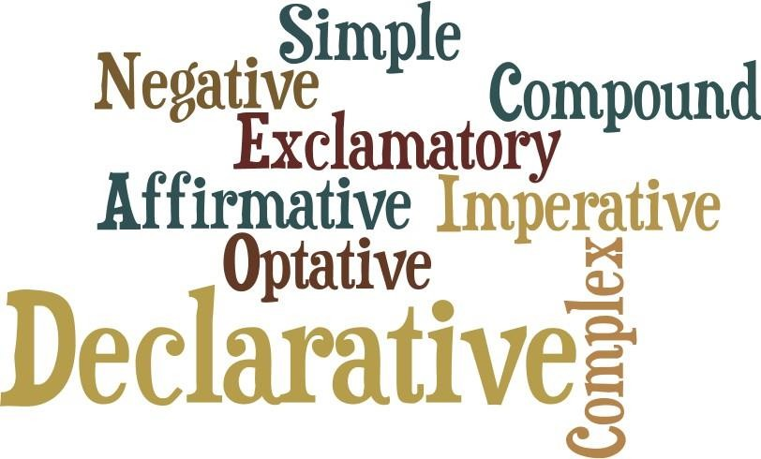

Types of Sentences Based on Form/Structure

Sentences

Simple

One Independent Clause
The moon shone brightly.

He could see mother coming.

Some students like to study in the morning.

Compound

Two or More Independent Clauses

Joe always kept a spare umbrella, but today he forgot to carry it. Mother baked the cake and waited for the guests to arrive.
Years passed, but there was no sign of Johnny returning home.

Complex

One Independent Clause with One or More Dependent Clauses The referee disqualified Rajiv even though it was the other player’s fault. Because he was weak, Larry was often excluded from sports and picnics. Martin didn’t meet them because he missed his bus to the airport.

Compound–Complex

At Least Two Independent Clauses with One or More Dependent Clauses

She shared her lunch with him and helped him find the canteen although she was too hungry.

She could open an art store or a restaurant because both are lucrative options.

If she is invited to the concert, she might come, but you will have to drop her home

Simple Sentences

A simple sentence has only one subject and one predicate.
- It has only one independent clause.

A simple sentence contains one subject and one verb.
- Simple sentences can be both short and long.

Examples:

The fish swam. Subject: The fish Predicate: swam Verb: swam

Gayatri went to the market in the evening.
Subject: Gayatri
Predicate: went to the market in the evening
Verb: went

- Simple sentences can have compound subjects and compound verbs.

Examples:
The dog howled and ran. Subject: The dog Predicate: howled and ran Verbs: howled, ran

Raman and Priya love mashed potatoes.
Subject: Raman and Priya

Predicate: love
Verb: love mashed potatoes

A simple sentence DOES NOT contain a dependent clause or another simple sentence.

Compound Sentences

A compound sentence has two or more simple sentences joined by

  - A comma followed by a FANBOYS word (coordinating conjunction)
The mouse jumped, and the cat ran after it.
Manju rose from her chair, but Sita had left the room.

A semicolon
The mouse jumped; the cat ran after it.
Manju rose from her chair; Sita had left the room.

  - A comma when simple sentences are being treated as items in a series. The mouse jumped, the cat ran after it, and Jeremy followed them. Manju rose from her chair, Sita left the room, and Hari started yelling.

F A N B O Y S

FOR AND NOR BUT OR YET SO

Complex Sentences

A complex sentence consists of one independent (main) clause and one or more dependent (subordinate) clauses.

The clauses can be joined by subordinating conjunctions or relative pronouns.

Examples:
The boy who is the captain of the team got injured yesterday. Independent Clause: The boy got injured yesterday Dependent Clause: who is the captain of the team Relative Pronoun: who

A puzzled mind will keep wondering until you finally decide something.
Independent Clause: A puzzled mind will keep wondering Dependent Clause: until you finally decide something Subordinating conjunction: until

When the doorbell rang, Jiten shut his textbook and rose to open the door.
Independent Clause: Jiten shut his textbook and rose to open the door
Dependent Clause: When the doorbell rang

Subordinating conjunction: when

Amrita paid the cab driver whose stained teeth made her look at him with disgust.
Independent Clause: Amrita paid the cab driver
Dependent Clause: whose stained teeth made her look at him with disgust
Relative pronoun: whose

Types of Sentences – Based on Meaning

What is a Sentence?
A sentence is a group of words that makes complete sense. It contains a subject and a verb, and may contain an object.

Rohit runs. (S + V)
Rohit runs at the race. (S + V + O) Sunita bakes.
Sunita bakes the pastries.

In the chapter on Idioms, Phrases and Proverbs, we have learnt that a phrase is a combination of words expressing something figuratively. Phrases must be used with other parts of speech to make a complete sentence.

Sentences can be divided based on
- Form
- Meaning

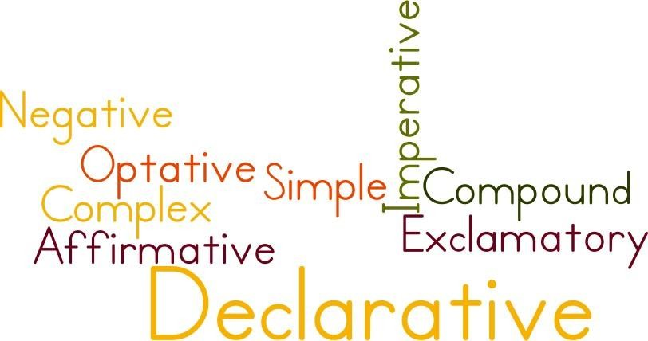Let us learn about the types of sentences based on meaning.

Types of Sentences Based on Meaning

The Sentence
Declarative
- Affirmative Declarative
- Negative Declarative
- Affirmative Interrogative
- Negative Interrogative
- Affirmative Imperative
- Negative Imperative
Interrogative
- Yes/no questions
- Yes/no questions with modal auxiliaries
- Wh- questions
- Alternative questions
- Question tags
- Rhetorical questions
- Echo questions
Imperative
- Suggestion, advice, warning
- Request
- Command or instruction
- Invitation
- Permission or prohibition
Exclamatory
- Joy
- Sorrow
- Shock
- Surprise
Optative
- Wish
- Prayer

A declarative sentence is a statement that conveys information. A declarative statement may be
- Affirmative Declarative
The guests have arrived. Mukul has finished dinner.

- Negative Declarative
I don’t have the bag right now. Priya did not shuffle those papers.

- Affirmative Interrogative
Will you share your sandwich with me? Have you paid the school fees?

- Negative Interrogative
Aren’t you going to introduce me to your friends? Doesn’t this painting look beautiful?

- Affirmative Imperative
Please tie your seatbelts.
Please switch off your mobile phones.

- Negative Imperative
Don’t touch any item without permission. Don’t misuse school property.

An interrogative sentence is used to ask questions. Interrogative statements can be classified into

Yes/no questions: These expect the listener to answer a yes or a no.
Did you lock the back door?
Haven’t you seen the Taj Mahal yet?

Yes/no questions with modal auxiliaries: Can be used to seek permission or advice, to request or question.
May I close the door now?
Can you tell which one looks better? Could you drop me to the bus stop? Must I block the access right now?

Wh- questions: These expect the listener to give detailed answers.
Which is the way to Janpath? What is your name?
Where did Mahatma Gandhi live? Why is the baby crying?

Alternative questions: These are used to ask the listener’s preference.
Do you want to order salad or milkshake?
Will you wait here for Jordon or should I drop you?

Question tags: These are short questions asked to conform or contradict a statement.
Will doesn’t own this property, does he? Suman is going to sell his land, isn’t he?

Rhetorical questions: These have the structure of a question but function as declarative sentences.
Do you think this food comes free? (One has to work hard and earn money to buy food.)
Is the school going to change its policy for one student?

Echo questions: These are direct questions that repeat a part of the question someone else asked.
Ragini learnt Tai Chi.
Ragini learnt what? Jyoti shopped from Milan.
Jyoti shopped from where?

An imperative sentenc
e can be used to exercise authority or to make polite suggestions/requests. Imperative statements can be classified into
- Suggestion, advice, warning
Kindly switch off the fans when not in use. You must add two spoonfuls of sugar to it.
You have exceeded your daily data usage today.

- Request
Please ask Bijoy to stop eating sweets.
Kindly remove your footwear before entering the premises.

- Command or instruction
Don’t open the gate until further instructions. Paste your photograph in the given box.

- Invitation
Come home tonight for dinner. Have some more cookies.

- Permission or prohibition
Come in.
Don’t take photographs here.

An exclamatory sentence expresses sudden rush of emotions.

Exclamatory statements can be used to express many emotions:
Wow! Mother bought me a new pair of shoes! (Joy) What a tragic end to such a beautiful life! (Sorrow) What! This pen costs 50 dollars? (Shock)
What a strange name! (Surprise) How rudely she talks! (Dislike) What a dirty hotel! (Disgust)

An optative sentence is used to express

- A Wish
May you get the best place!
May you meet the best people on your trip.

- A Prayer
May Rasika come back home healthy from the hospital. May Rajwant win the case.

