






What are Tenses?
Tenses

Grammer | Tenses

Tense is something which tells us when the action expressed by the verb took place. There are three main divisions of tenses.

- Past Tense: The past tense is used to talk about actions which took place in the past.


They sang Christmas carols. Anshul was watching cartoons.
Rahul had read all the works of Shakespeare. Tim had been working non-stop for 10 hours.
- Present Tense: The present tense is used to talk about actions which take place in the present.


The cat yowls every night. Diane is leaving now.
Vilas has cooked lunch for us.

The house has been lying unattended.
- Future Tense: The future tense is used to talk about actions which will take place in the future.


Hansel and Gretel will visit the Gingerbread House. Farid will be sleeping.
The food will have been spoilt.

Craters would have been forming on the surface of the planet.

Grammer | Tenses

Present Tense

The present tense can be divided into three sub-categories:
- Simple
- Continuous
- Perfect

Simple Present Tense


Examples of sentences in the simple present tense:

Habitual actions Rishabh rises at 7 every day. Grandpa feeds the pigeons. |  | Events of the near future  I go shopping today. My train leaves at 12.
Ability Gaurav runs very fast. Jayanti speaks French. |  | Facts  The Earth is the third planet from the Sun.  Chemistry is the study of the composition of matter.
 | Opinions and words of wisdom Samantha is the rudest girl I have known. All that glitters is not gold.

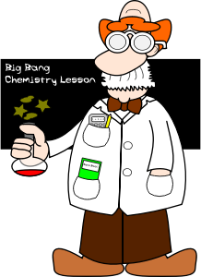Simple present tense on a timeline:
Now
Simple Present Tense Ideas which are generally true.

Grammer | Tenses
Present Continuous Tense

- The present continuous tense is used to express actions which are currently in progress.
- Progressive helping verbs (is, am, are) are used along with the ‘-ing’ form of the verb.

Helping Verbs | Main Verb (-ing form)
is | eating
are | lying

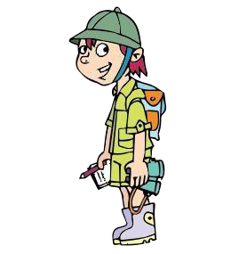Examples of sentences in the present continuous tense:

Actions which are in progression

The cat is lapping water. Meena is cooking food.

Near future

I am going on a treasure hunt tomorrow. Preeti is going home tonight.

Present continuous tense on a timeline:

Now

Past Present Continuous Future
Action in progression

Present Perfect Tense

- The present perfect tense is used to express an action which may have happened at a specific time before now.
- Perfect helping verbs (has, have) are used with the past participle form of the verb.

Helping Verbs | Main Verb (Past Participle)
has | reported
have | listened

- The present perfect tense is never used when the time or date of the action is mentioned.
  - The milkman has delivered the milk in the morning. Incorrect
  - The milkman delivered the milk in the morning. Correct

Grammer | Tenses
Examples of sentences in the present perfect tense:

Recently completed action When the time of completion is unspecified

The ninja has emerged from the shadows. Rama has baked a pie.

The milk has gone cold. Sanjay has flown a plane.

A past action which is still in continuation Changes which have happened over time

The villain has plotted against the girls from the beginning.

Chris has waited for hours.
Gregory’s face has aged with time.

Gradually, you have achieved what you wanted to.

When the consequences are more important than the action itself

A past action whose benefits can be felt to this day

It has rained for three days. (it’s flooded) I have taken some pills; I feel better already.

She has trimmed the last leaf. (no leaves left)
Rob has fixed an air conditioner in his room; he is not afraid of summer anymore.

Present perfect tense on a timeline:

Action completed in the past
Now
Present Perfect Tense Action which happened at a specific time before now.

Grammer | Tenses

Past Tense

The past tense can be divided into four sub-categories:
- Simple
- Continuous
- Perfect
- Perfect continuous

Simple Past Tense

- The simple past tense is used to express an action which was completed at one point of time in the past.




Examples of sentences in the simple past tense:

Completed actions  Gerald wore a blue suit. Tarun had a delicious lunch. |  |  | Habitual actions of the past
 |  |  |  | Fred practised martial arts. Deepak went for evening walks.
Past facts or generalisations

Greek warriors were some of the finest warriors of their time.

The jesters amused the courtiers.

Simple past tense on a timeline:

Simple Past Tense
Now

Grammer | Tenses
Past Continuous Tense

- The past continuous tense is used to express actions which were in progression at one point of time in the past.
- 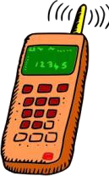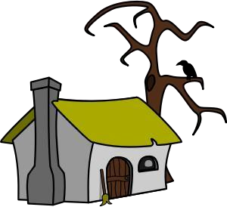It is formed when progressive helping verbs (was, were) are added to the ‘-ing’ form of the main verb.

Helping Verb | Main Verb (-ing)
was | doing
were | talking

Continuing actions of the past  The dog was juggling balls on a unicycle.  The businessman was talking to his associate on the phone. |  | To mention the action of longer duration while comparing two actions  The children were playing when their mom returned home.  I was sleeping when the phone rang.
To talk about a progressive action in a narrative

The raven was sitting atop a tree.

The monk was observing the man in silence.

Past continuous tense on a timeline:

Past Continuous Action in progression
Now

Grammer | Tenses
Past Perfect Tense

- The past perfect tense is used to express an action which may have happened at a specific time before another action began in the past.
- The perfect helping verb (had) is used with the past participle form of the verb.
Helping Verbs | Main Verb (Past Participle)
had | Started
had | Gone
ples of sentences in the past perfect tense:
Action completed in the past before another action began  I had just baked a cake when the guests arrived.  Neha had just ordered a pizza when the bell rang. | To change from direct speech to reported speech  Suresh said, “I have a dog.”  Suresh said that he had had a dog.  Grace stated, “I read the book.”  Grace stated that she had read the book.

Exam

Past perfect tense on a timeline:

Action 1 Action 2 Now

Past perfect tense
Action which happened before another action in the past

Grammer | Tenses
Past Perfect Continuous Tense

- The past perfect continuous tense is used to express an action which may have started at a particular point of time in the past and may have ended at another point of time in the past.
- It is formed out of the addition of the perfect helping verb (had) to the participle form of progressive helping verbs (been) and finally to the ‘-ing’ form of the main verb.

Helping Verb | Helping Verb (Participle  form) | Main Verb (-ing)
had | been | buying
had | been | playing

Examples of sentences in the past perfect continuous tense:
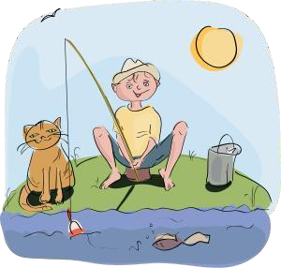

An action which may have started and may have gone on for a while in the past

They had been watching television. Swapnil had been fishing.

Past perfect continuous tense on a timeline:



Action started
Action ended
Now

Past Perfect Continuous

Grammer | Tenses
Future Tense

The future tense can be divided into four sub-categories:
- Simple
- Continuous
- Perfect
- Perfect continuous

Simple Future

- The simple future tense is formed by adding the modal auxiliaries ‘will’ or ‘would’ to the simple present tense of the main verb.

Modal Auxiliary |  | Main verb
will |  | leave
would |  | come
 | Events of the future  There will be a puppet show. Winter will be here soon. | Consequences of present actions  If you don’t preheat the oven, you will burn  the bread.  If the sailors are not careful, stowaways may  get into the ship.
 | Expressing promise or a plan  We will open the presents in the morning.  I will introduce you to my business associate. | Future facts or habitual actions  Neha will board the train to Jaipur tomorrow.  He will be crowned the king of England.

Simple future tense on a timeline:

Now Simple Future

Grammer | Tenses
Future Continuous Tense

- The future continuous tense is formed by adding the modal auxiliaries ‘will’ or ‘would’ and the progressive helping verb ‘be’ to the ‘-ing’ form of the main verb.

Modal Auxiliary | Progressive Helping Verb | Main verb
will | be | going
would | be | breaking

Examples of sentences in the future continuous tense:

Future events which will be in continuation  I will be writing the exam at this time today.  Carol and Gerald would be driving their car home right now. |  | Talk about future events or plans  Rajesh will be working for us.  We will be making Christmas pudding.


Future continuous tense on a timeline:

Now Future
Continuous Action in progression

Grammer | Tenses
Future Perfect Tense

- The future continuous tense is formed by adding the modal auxiliaries ‘will’ or ‘would’ and the perfect helping verb ‘have’ to the participle form of the main verb.

Modal Auxiliary | Perfect Helping Verb | Participle Form of Main verb
will | have | eaten
would | have | taken



Future events which will be completed on or by a particular time

Danish would have sent the letter by tomorrow.

All the food in the pantry will have depleted by the end of the week if we don’t replenish it.

Future

Now Action Completed

Future Perfect Tense

Future Perfect Continuous Tense

- The future perfect continuous tense is formed by the addition of the modal auxiliaries (will or would); perfect helping verb (have); the past participle form of a progressive helping verb (been); and the present participle (-ing) form of the main verb.

Modal Auxiliary | Perfect Helping Verb | Past Participle Form of  Progressive Helping Verb | Present Participle Form  of Main Verb
will | have | been | talking
would | have | been | sleeping

Grammer | Tenses
Examples of sentences in the future perfect continuous tense:

Sajid will have been talking to Apurva for half an hour before Rahul calls.
Duration before something happens in the future

Toto would have been gnawing at the bone for two hours before I give him something to eat.
Girish would have been working as an electrical engineer for fifteen years by 2015.
An action which will start at a particular point in the future and continue up to another point

Janet will have been sleeping for 15 hours straight by 8 am tomorrow.

A cause for something in the future

Rashid would be exhausted since he will have been working without a break.

My French will improve as I would have been learning it for two years intensively.

Future perfect continuous tense on a timeline:



Now Action
started
Action ended

