






Functions of Prepositions

What do Prepositions do?

We have studied in the previous chapter that a preposition describes the relationship of its object with another word or idea in the sentence. In this chapter, we will study the various functions performed by prepositions to express these relationships.

What are the Functions of Prepositions?

A preposition can be used to indicate

1. Place | 6. Purpose
2. Time | 7. Agent
3. Destination | 8. Contrast or Concession
4. Origin | 9. Measure
5. Motion | 10. Possession

Prepositions Indicating Place

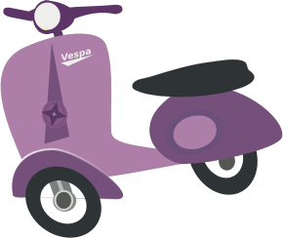Prepositions are used to indicate the spatial relationship (related to space) between the words in a sentence.

The jars are placed on the shelf. | The Shahs lived in this neighbourhood.
We met our friends at the library. | The tiger jumped over the roof.
I found a piece of paper under the rock. | I parked my scooter by the wall.

Prepositions Indicating Time

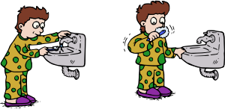Prepositions are used to indicate the temporal relationship (related to time) between the words in a sentence.

The train arrived at midnight. | Mr Mehta is flying to Delhi on Monday.
Be sure to reach the auditorium by 10 PM. | The company has been bankrupt for three years.
She has been driving a car since her youth. | Jay brushes his teeth before sleeping.

Prepositions Indicating Destination

Prepositions are used to indicate the direction of the movement of the subject.

The thieves moved towards the exit. | He made a dash for the door.
The dog jumped at the intruder. | The young woman ran to her room.
Reena crawled onto her bed. | The mermaid dived into the water.

Prepositions Indicating Origin

Prepositions are used to indicate origin or source of an action or movement of the subject.

The Reddys hail from Telangana. | Goddess Aphrodite emerged out of the ocean.
She came back from her trip. | The phoenix rises out of its own ashes.
A putrid smell wafted out of the room. | Ratnagiri is where the best mangoes come from.

Prepositions Indicating Motion

Prepositions can be used to indicate the movement of the subject in the sentence.

The snake darted across the floor swiftly. | Rajesh danced to his wife’s tunes.
The knife went through the block of cheese. | Here we go round the mulberry bush!
The students marched along the road. | The crocodile swam across the river.

Prepositions Indicating Purpose

Prepositions can be used to indicate the utility or purpose of the subject of the sentence.

The cloth is used for wiping. | I need a bigger knife to cut this.
Jars are used to store peanuts. | A servant was called to assist her.
I need these books for reading. | Jamuna was hired for typing.

Prepositions Indicating Agent

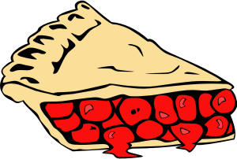Prepositions are used to indicate that something is responsible for an action done on the subject of the sentence. The action is always expressed in the passive voice.

Melissa was hit by a ball. | Ivan was employed by an agency.
Subbu spoke with conviction. | He thrives on people’s kindness.
The pie was baked with lard. | Leena achieved it with perseverance.

Prepositions Indicating Contrast or Concession

Prepositions can be used to express contrast between two ideas in a sentence.

For all your arrogance, you are incredibly stupid. | With all its faults, this software is the best.
Notwithstanding his lies, the jury saw through his character. | Despite Lata’s protests, Raju left for Chennai.
For every action, there is an equal and opposite reaction. | In spite of his wealth, Madhukar was greedy.

Prepositions Indicating Measure

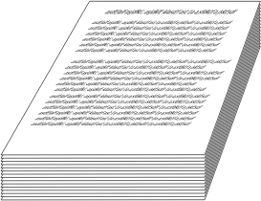
Prepositions can be used to express measurement.

I am taller than you by an inch. | I drove for two hours.
The sugar is sold for Rs 30 a kilo. | The victim lost blood by the minute.
Paper is sold by the bundle. | Reena purchased them for twenty rupees.

Prepositions Indicating Possession

Prepositions can be used to establish possession of a noun by the other.

The file belongs to the office. | I can hear the sound of the sea.
These are the complete works of William Shakespeare. | Students of the chemistry class praised him.
It is an age of enlightenment. | Oh, that naughty dog of mine!

Prepositions

What is a Preposition?

A preposition is a word which usually precedes a noun, a pronoun or a gerund. The word which follows the preposition is called the object of the preposition.
The man is standing at the gate. The flowers were given to her.
I am tired of talking.

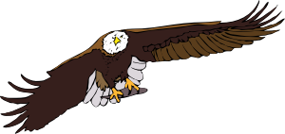Prepositions show the relationship of its object with another word or idea in the sentence.
Examples:

1. The car moved towards the tunnel.
(Relationship between a car’s movement and the tunnel)

2. The eagle flies in the sky.
(Relationship between the eagle’s flight and the sky)

What are the Types of Prepositions?

There are five basic types of prepositions:

- Simple prepositions

- Compound prepositions

- Double prepositions

- Participial prepositions

- Phrase prepositions

Simple Prepositions

Prepositions which consist of just one word are known as simple prepositions.
to | for | at | by | in | on | off | with | through | over
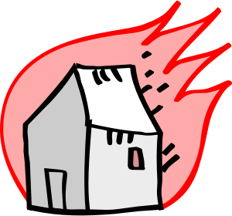

The Sharmas house was set on fire. Granny will visit us in May.
Manjula smiled at the visitor. They went off the main road.

Compound Prepositions

Prepositions which are formed out of prefixing a preposition (a- or be-) with a noun or an adjective are known as compound prepositions.
across | amidst | beneath | inside | along | beyond | between | among | behind | within

A bridge was built across the river. The mouse hid inside the cupboard. Wild flowers grew along the road.
There is no honour among thieves.

Double Prepositions

When two prepositions come together to convey a single idea, the pair is called a double preposition.
along with | apart from | inside of | from behind | up to | down on | away from


She went along with her mother.
Apart from a big bungalow, Mr Moorthy also owns a flat.
Except for Asha, everyone in the class fared badly. Meenal was always two steps ahead of her rival Akshaya.

Phrase Prepositions

Phrase prepositions are formed when a group of words come together to function as a unit. These prepositions usually follow the Preposition + Noun + Preposition structure.

Preposition | Noun | Preposition | Phrase Preposition
in | accordance | with | in accordance with
by | the virtue | of | by the virtue of
in | regard | to | in regard to
in | front | of | in front of
in | order | to | in order to
on | behalf | of | on behalf of
for | the sake | of | for the sake of
- | owing | to | owing to

The police arrested the offender in spite of his resistance. Marjorie’s performance is pale in comparison to Betty’s.
Darius has no trouble winning friends owing to his friendly nature.
In the course of my career, I have never seen someone as vile as he is.

Participle Prepositions

When a verb ending in –ing or –ed/–en functions as a preposition, it is called a participle preposition.
considering | notwithstanding | assuming | given | following | regarding | gone
Given the nature of the situation, it is fair that he apologises.
Assuming she is the mother of the child, the judge should rule in her favour.
Regarding yesterday’s problem, I have found a solution for it.
Notwithstanding all his wealth, he was tried like a common man.

