






What are Articles?
Articles

- Articles are words used to qualify nouns.
- ‘The’, ‘A’ and ‘An’ are the articles used in English.
- Articles do not have meanings of their own, but their presence or absence affects the significance of nouns in sentences.
- They appear before nouns and function in a way similar to adjectives; they are, in fact, demonstrative adjectives.

Let us look at a few examples:



- The bridge
- A blue-feathered small bird
- An amazing, unbelievable, awe-inspiring instance

In the above examples, we see that the articles are used immediately before a noun in the first case; before two adjectives and a noun in the second case; and before three adjectives and a noun in the third case. Therefore, we can say that an article may sometimes be used before a noun or sometimes be separated from the noun by adjectives.

Types of Articles

The Definite Article

•

‘The’ is a definite article. We use ‘The’
With nouns to refer to specific nouns

- The Russian doll on the shelf
- The homeless man on the pavement
- The Duke of Edinburgh
•

- To represent a noun kind


- The whale is an enormous fish.
- The owl is a nocturnal bird.
- The coconut tree is known as ‘Kalpavriksha’.

- With the names of oceans, rivers, seas, mountain ranges, peaks, forests, gulfs and a group of islands


- The Alps
- The Nile
- The Arctic Ocean
- The Black Forest
- The Lakshadweep

- With the names of historical monuments
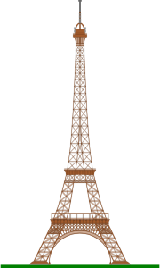

- The Eiffel Tower
- The Pyramids of Giza
- The Leaning Tower of Pisa
- The Easter Island Statues
- The Sydney Opera House

- With the names of countries which are titles


- The United States of America
- The United Arab Emirates
- The Republic of China

- With the names of certain countries and provinces

- The Punjab
- The Hague
- The Ukraine

- With the names of things which are unique or are one of a kind


- The Sun
- The Moon
- The sky

- With proper nouns, only if there is an adjective between the two

- The annoying Mr Shekhar
- The talented Leann
- The great Shakespeare

- With proper nouns, to specify a particular person

- She is not the Katherine I had in mind.
- This is the same Mr Suleiman whom I met yesterday.

- With superlative adjectives


- The best slice of cake I have ever had
- The most important person in the room
- The tallest boy in the class

- With adjectives
In such cases, the adjective functions like a noun.

- The greedy will never be satisfied.
- Paradise is reserved for the brave.
- The good will never lose to the evil.

- With surnames, to represent the whole family

- The Guptas will be visiting us tomorrow.
- The Folgers were in a hurry.
- The Subramaniums are our neighbours.

- 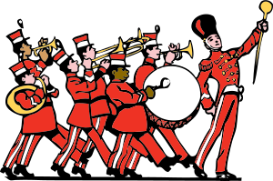Before musical instruments

- He can play the flute.
- The band played the trumpet.
- Mr Woods plays the violin beautifully.

Indefinite Articles

- ‘A’ and ‘An’ are indefinite articles. They are used to
- Refer to nouns which are not specific or certain
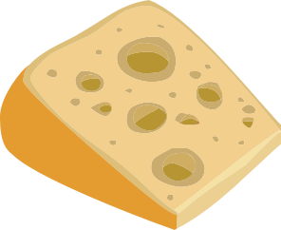

- A piece of cheese
- A tall building
- A criminal
- Signify ‘one’ in the numerical sense


- There was a feather on his hat.
- I need a room to keep my belongings in.
- Leela wanted to have a word with me.
•
Refer to nouns which the speaker/hearer is not sure about
Convert a proper noun to a common noun

- I cannot recall the name of a man who lived here.
- A woman was here asking for you.
- A magician was hired to entertain the guests.

•

- There is a Kanchan in my class.
- A Delilah betrays a Samson again.
- A Gandhi is born today.

Differences between ‘A’ and ‘An’

- The articles ‘A’ and ‘An’ are similar in function.
- That is, they both qualify nouns that are uncertain.
- However, ‘A’ precedes nouns that begin with consonant sounds.
- The article ‘An’ precedes nouns that begin with vowel sounds.

Using ‘An’

‘An’ is used
- With nouns which begin with vowel sounds


- An ant
- An elephant
- An antelope

- With nouns which may begin with a consonant letter but may have a vowel sound

- An honest person
- An heir to the throne
- An hour

- With abbreviations which begin with a vowel sound

- An FIR
- An MBA
- An NYU graduate
- Sometimes, words which begin with the letter ‘H’ may be pronounced without stressing on the first syllable (pronounced istoric instead of historic). In such cases, ‘An’ is used as an article.

- An historic episode
- An hotel

Nouns without Articles

Sometimes, articles are not used with nouns. Articles are not used

- When the noun is used in a universal sense. It could represent all of its kind.

- Child is the father of man.
- Man is a social animal.
- Before the names of material nouns

- Copper is used for making wires.
- Tea is plucked from its shrub.
- Silver is used for making ornaments.

- While using proper nouns which are names of people or places

- Kala is a fantastic dancer.
- Beirut is the capital of Lebanon.
- Romania is a European country.

