






Adjectives: Participles and Nominal Adjectives

Participles

What are Participles?

Let us read the following sentences.

1. The revellers were feasting on the food.
2. Feasting on the food, the revellers sang songs.

In the above sentences, the word feasting is used in two different ways.
- In sentence 1, the word feasting is used as a verb; its subject is the word revellers.
- In sentence 2, the word feasting qualifies the noun revellers. It is formed from the verb feast. It also has an object food. Therefore, it has the properties of a verb and an adjective.
- The phrase Feasting on the food is a participial phrase.

Let us look at more examples.

1. Fatima is singing to her baby.
2. The singing bird perched itself on a branch.

In the above sentences, the word singing is used in two different ways.
- In sentence 1, the word singing is used as a verb; its subject being Fatima.
- In sentence 2, the word singing qualifies the noun bird.
- It is formed out of the verb sing.
- The word not only expresses the action of the noun but also acts as an adjective.
- The word singing in sentence 2 is therefore a participle because it looks like a verb but acts like an adjective.

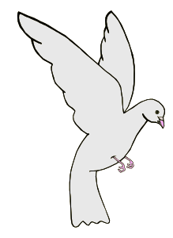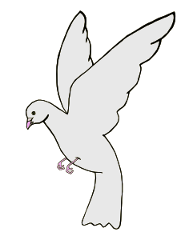

Participles are defined as words that are formed from verbs but have the qualities of adjectives.

Participles are grouped into two categories according to their tenses—past participle and present participle.

- Present participles end in –ing.
  - The captain went down with the sinking ship.
  - Eating a bowl full of cornflakes, Rajesh answered the door.

- Past participles end in –ed or –en.
  - Mr Shatrugan was impressed by the new intern.
  - She brought a pair of bejwelled earrings.

Examples of Past and Present Participles

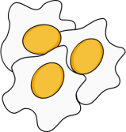Verb

Past Participle

Present Participle

Fry
The fried eggs
A frying pan

Boil
Boiled vegetables
The boiling point

Interest
Interested buyers
An interesting fact

Embarrass

The embarrassed teenager
An embarrassing situation

Write
The written note
The writing pad

Confuse
The confused pedestrian
The confusing sum

Amuse
Amused onlookers
An amusing anecdote

Bore
Bored students
Boring lesson

Hang

The hanged criminal

The hanging clothes

Overwhelm
Overwhelmed lady
The overwhelming evidence

Shave
His shaven head
The shaving machine

Bend
The bent rod
The bending branch

Nominal Adjectives

Read the following sentences.
- The bride was rich, but the bridegroom was poor.
- The rich will always exploit the poor.

- In sentence 1, the words rich and poor function as adjectives.
- However, the same words when used in sentence 2 function as nouns.
- They are preceded by the definite article.
- The phrases the rich and the poor used in sentence 2 are known as nominal adjectives.
- Nominal adjectives look like adjectives but operate like nouns.



Nominal adjectives represent an entire category or class of nouns. They always have articles preceding them.

What do nominal adjectives represent?
- The hazardous
- The young
- The living
- The inspirational
Nominal adjectives represent nationalities.
- The British
- The Dutch
- The Germans
- The Japanese
- The Indian

  - Nominal adjectives represent a class marked by their qualities.

•

  - Comparative and superlative adjectives function like nominal adjectives.


- The better of the lot
- The worst
- The most important

Points to remember

Nominal adjectives are always preceded by the definite article.
- The horrible

Nominal adjectives can be modified by other adjectives or adverbs.
- The extremely unfortunate
- The truly honest

Grammer | Adjectives

Adjectives: Royal Order of Adjectives

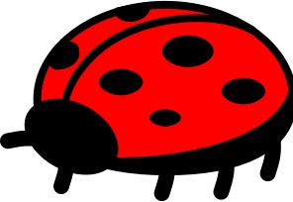Royal Order of Adjectives

1) A red big bug sat on a green small leaf.

Read these sentences.

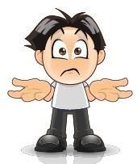Which sentence seems grammatically correct to you? How are the two sentences different from each other? The order of the adjectives in both the sentences is different.
?

2) A big red bug sat on a small green leaf.
- In sentence 1, red big and green small are the sequences.
- In sentence 2, big red and small green are the sequences.

Obviously, sentence 2 sounds right to you. But how did you arrive at that answer?
Knowing how to arrange the adjectives is intuitive.
Speakers of English instinctively know that
big red bug is correct and red big bug is incorrect.

There is an order which governs the placement of adjectives in a phrase. In English grammar, we call it the Royal Order of Adjectives.

Royal Order of Adjectives

If there is more than one adjective qualifying a noun, then they all have to be arranged in a particular order. This order is predetermined and comes naturally to habitual users of English. Let us learn more!



The expected adjective order is

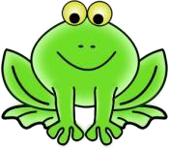The Royal Order

Physical qualities

 |  |  | 3  Opinion | 4  Size | 5  Age | 6  Shape | 7  Colour | 8  Origin | 9  Material | 10  Participl  -e
1  Determin- ers | 2  Numeral  -s

- Determiners: Determiners are words like articles and demonstrative adjectives that precede nouns.
  - The, a, an, that, these

- Numerals: Adjectives of number which show the numerical value of nouns come next.
  - One, three, many, some

- Opinion: Adjectives which are based on opinions. They can differ from person to person. Something that is beautiful or interesting to one person may not hold the same meaning for somebody else.
  - Pretty, good, nice, evil, rotten

- Size: Adjectives which express the size of the nouns
  - Gigantic, huge, minuscule, small

- Age: Adjectives which express the age of the noun
  - Old, new, prehistoric

- Shape: Adjectives which express the shape of the noun
  - Triangular, round, prismatic, oblong

- Colour: Adjectives which express the colour of the noun
  - Red, blue, yellow, green, maroon, golden

Note
Gold is material. Golden is colour.

Metal is material. Metallic is colour.

Silver is material. Silvery is colour.

- Origin: Adjectives which express the nationality or the place of origin of the noun
  - Hungarian, Indian, American, Polish, Gujarati

- Material: Adjectives which tell us about the materials which make up the noun
  - Glass, silk, wooden, brick, paper

- Participle: Adjectives which give the purpose for using certain nouns or its qualities.
  - Sewing, frying, sleeping, beloved, frozen

Let us look at a few examples.

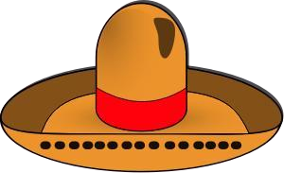
Determiner Opinion
Colour
Origin
Material
Noun
A
beautiful
brown
Mexican
felt
hat


Determiner
Size
Colour
Material
Participle
Noun
A
small
grey
stainless steel
frying
pan
Numerical
Age
Shape
Colour
Origin
Noun
One
ancient
circular
golden
Roman
coin
Determiner
Opinion
Participle
Noun
That
fat
smiling
crocodile

Remember!
These rules are not cast in stone; a few exceptions are possible.
For example, one can say a black little book instead of a little black book to stress on the
blackness of the book.
But predominantly, these rules prevail when it comes to sequencing adjectives for nouns.

Adjectives: Types of Adjectives

Types of Adjectives

What are Adjectives?

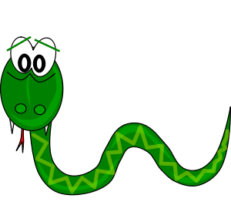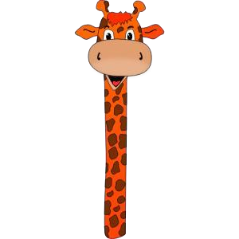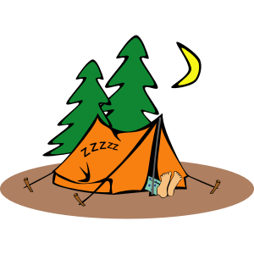Adjectives are words that tell us more about nouns. They tell us about

Quality
  - Beautiful, sly, slithery, cold, evil, busy

Quantity
  - Some, more, much, 5 kg, 13

Colour
  - Green, silvery, bluish, metallic, red

Origin
  - Mongolian, Arabic, Maharashtrian, Subterranean

Shape
  - Rectangular, triangular, round

Size
  - Big, small, tall, stout, thin

Age
  - Old, new, prehistoric

I’m not fat!

Slithery? Who?
Me?

I am the tallest here!

Placement of Adjectives

There are two ways in which we can use adjectives in English.

- Before the nouns they qualify
  - Three sticks, a queer sight, some gentlemen

Note:
Articles ‘A’, ‘An’ and ‘The’ are also adjectives since they precede nouns and qualify them.

- After forms of the verb ‘to be’ and with others such as ‘looks’, ‘seems’, ‘sounds’, ‘feels’, ‘smells’ etc.
  - The house looks magnificent.
  - The boy seems nervous.
  - I am busy.
  - The camper was asleep in his tent.
  - They were victorious in their efforts.

Adjective of Quality

An adjective of quality is a word which indicates the quality or the attribute of a noun.

- To understand the nature of the noun, we ask the question ‘What kind of?’ to the noun. The answer which we get is the adjective of quality.

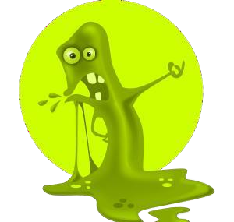
- This is a slimy monster.

What kind of monster?

Slimy

Let us look at a few examples.


Sheila was the main nurse.
The boy brought home a shabby dog.
The night is young.
Tabitha was a fat woman.
The sword had a golden handle.
Mallika is intelligent.
The clouds have a silvery hue.
Tariq is an obedient boy.
Doctor Agarwal is a good man.
King Arthur’s shield was very ornate.

Adjective of Quantity

An adjective of quantity tells us about the quantity of a noun.

- Some, many, few, little, less, much, more, enough, sufficient are some examples.

- It describes the number of countable nouns.
  - The three musketeers, many black birds, a few enemies

- It describes the volume, amount or quantity of uncountable nouns.
  - Some milk, three kilo rice, much water

- To understand the quantity of the noun or pronoun, we ask the question ‘How much/many?’ The answer we get is the adjective of quantity.

There is some rice in this bowl.
How much rice?
Some
- It can express an indefinite amount or quantity.
  - much water, less time, some people

- It can also express a definite number.
  - five people, three little pigs, 5 kilo rice

- Adjectives like much, little and less are used with uncountable nouns.
  - much time, a little water

- Adjectives like many and few are used with countable nouns.
  - many bottles, few children

Let us look at a few examples.
There is still some pride left in me.
Two doves were sitting on a branch.
We have enough money to last us a lifetime.
Maria had little patience with her son.
You wasted so much time.
Sabita has two sons.
I have a few friends in dance class.
We could see many stars in the sky.

Demonstrative Adjectives

Previously, we learnt about demonstrative pronouns which point towards their antecedents. In this chapter, we learn about demonstrative adjectives.

- Adjectives like this, that, these and those are demonstrative adjectives.

- They help the reader or listener understand what or who exactly is being addressed.

- ‘This’ and ‘that’ are used for singular nouns.
  - This cat, that house, this river, that woman

- ‘These’ and ‘those’ are used for plural nouns.
  - These days, those gentlemen, these toys, those moments

Let us look at a few examples.


- That man is cooling his heels in the jail as we speak.

- Scarlet is one of those women who would do anything to save a penny.

- These confectionaries are very delicious.

- This seat is reserved for the chief guest.

Interrogative Adjectives

Interrogative adjectives are those which help in framing questions by appearing before the noun that they qualify.

- 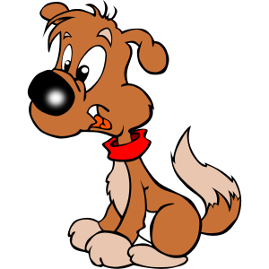What, which, whose are the three interrogative adjectives used in English.

- Which bus do we board?

- What excuse will you provide?

- Whose little dog is this?

- Unlike interrogative pronouns, these adjectives cannot stand on their own and they always appear before a noun.

Possessive Adjectives

Possessive adjectives, like possessive pronouns, show ownership or possession of nouns to pronouns.

- My, your, his, her, our, its, their are possessive adjectives.
- They appear before the noun they qualify.



To differentiate between a pronoun and an adjective, check where the word is placed.
- If the word appears before a noun, it is an adjective.
  - That man
  - Which bag
- If the word is at a distance from the noun with other words in between, it is a pronoun.
  - That is the man.
  - Which is the best?

His car was damaged in the accident.
Henry was proud of his blue shoes.
My computer is not working properly.
Your mother is busy.
The dog wagged its tail.
Their voices echoed in the hall.
Remember:
Never add an apostrophe with possessive adjectives.
It’s - incorrect Its - correct

